DESIGN DEVELOPMENT OF A WEB - BASED LEGISLATIVE RESEARCH POLICY ANALYSIS, AND IMPACT EVALUATION SYSTEM FOR MANILA CITY HALL TO ADDRESS MANUAL POLICY ANALYSIS AND DELAYED LEGISLATIVE DECISION MAKING WITH AI - ASSISTED ANALYTICS AND INTELLIGENT DECISION SUPPORT

A Capstone
Presented to the Faculty of
The College of Computer Studies
Bestlink College of the Philippines

In Partial Fulfilment
of the Requirements for the Degree
Bachelor of Science in Information Technology

Caspe, Christian M.
Panen Daniel P.
Quintana Jhonel O.
Salas, Stephen Jay D.
Salim Lorence B.

TABLE OF CONTENTS
Page
TITLE PAGE i
APPROVAL SHEET ii
ACKNOWLEDGMENT iii
DEDICATION v
ABSTRACT vi
TABLE OF CONTENTS viii
LIST OF TABLES xiii
LIST OF FIGURES xiv
LIST OF APPENDICES xv
CHAPTER
1 INTRODUCTION
1.1. Project Background and Motivation 1
1.2. Problem Statement 3
1.3. Project Vision and Scope 7
1.4. Objectives and Goals 8
1.5. Significance and Relevance 10
1.6. Definition of Terms 12
1.7 Structure of the Document 14

CHAPTER
2 RELATED LITERATURE, STUDIES, AND TECHNICAL
BACKGROUND
2.1 Review of Related Literature 16
2.2 Analysis of Related Studies
and Existing Systems 18
2.3 Agile Scrum Methodology
2.4 Emerging Technologies, Intelligent
Systems, and Standards in Modern
Information Systems 20
2.4.1 Microservices Architecture 22
2.4.2 Artificial Intelligence (AI) 24
2.4.3 Internet of Things (IoT) 26
2.4.4 Data Analytics and Business
Intelligence 28
2.4.5 Polyglot Persistence 30
2.4.6 Cybersecurity 32
2.4.7 Data Privacy 34
2.4.8 Software Quality Standards 36
2.4.9 Cloud Computing 38
2.4.10 Edge Computing 40

2.5 DevOps Culture and CI/CD Practices 42
2.6 Enterprise Architecture & System Integration 44
2.7 Conceptual Framework 46
2.8 Theoretical Paradigm 48

CHAPTER
3 METHODOLOGY AND PROJECT MANAGEMENT
3.1 The Adapted Agile Scrum Framework 52
3.1.1 Team Roles and Responsibilities
3.1.2 Scrum Events
3.1.3 Scrum Artifacts
3.1.4 Toolstack
3.2 Architectural Design Decisions 56
3.2.1 Why Microservices? Justify the choice over Monolithic architecture.
3.2.2 Core Architectural Patterns Used
3.3 Development, Operations, and Quality Assurance (QA) Methodology 60
3.3.1 DevOps Toolchain
3.3.2 CI/CD Pipeline Design
3.3.3 Testing Strategy
3.4 Innovation Framework 62

Chapter 1
INTRODUCTION
1.1 Project Background and Motivation
The continuous advancement of information technology has changed how organizations manage information and improve decision-making. In legislative offices, digital systems help organize legislative documents, support policy analysis, and provide timely access to information needed by policymakers. As technology continues to evolve, adopting information systems has become essential for improving efficiency and supporting evidence-based legislative processes.
Legislative research, policy analysis, and impact evaluation are essential in developing ordinances and resolutions. These processes require legislative researchers and policymakers to review ordinance, legal references, and related documents before making informed decisions. According to Aula (2023), evidence-based policymaking relies on the timely use of credible research and reliable information. However, as the number of legislative documents continues to grow, managing and analyzing information manually becomes more difficult and time-consuming, making it challenging to support efficient legislative decision-making.
The Office of the Councilor in Manila City Hall is responsible for preparing ordinances and resolutions that address the needs of the community. However, managing a growing number of legislative documents through manual processes can make research, document retrieval, and policy analysis more time-consuming. These challenges may slow legislative work and make it more difficult to access the information needed for informed decision-making.
Government Information Quarterly (2022) emphasized that digital government initiatives improve operational efficiency by providing centralized access to information and streamlining administrative processes. Likewise, Wirtz, Weyerer, and Kehl (2022) explained that Artificial Intelligence can support data analysis and decision-making while ensuring that final decisions remain under human supervision. Despite these developments, many existing systems still focus mainly on document storage and lack integrated tools for legislative research, policy analysis, and impact evaluation.
To address the identified challenges, this study proposes the design and development of a Web-Based Legislative Research, Policy Analysis, and Impact Evaluation System for the Office of the Councilor in Manila City Hall. The system is intended to simplify legislative research and policy analysis by providing a centralized platform supported by AI-Assisted Analytics, a Rule-Based System, and Natural Language Processing (NLP). Through these technologies, the study aims to reduce manual work, improve access to legislative information, and assist legislative personnel in conducting research and policy evaluation more efficiently while ensuring that all legislative decisions remain under the authority of the councilor and authorized personnel.
1.2 Problem Statement
This study seeks to address the challenges of manual policy analysis and delayed legislative decision-making in Manila City Hall through the development of a web-based legislative research, policy analysis, and impact evaluation system. Specifically, this study aims to answer the following questions:
Problem | Description
Manual Legislative Research and Policy Analysis | The legislative office of Manila City Hall still relies on manual methods for legislative research and policy analysis. Personnel spend a lot of time searching through ordinances, resolutions, and other legal documents, making the research process slow and less efficient.
Fragmented and Unorganized Legislative Information | Legislative documents are stored in different locations instead of one centralized system. Because of this, personnel must gather and organize information manually, which can lead to duplicated work, inconsistent records, and slower policy analysis.
Delayed Legislative Decision-Making | Manual research and slow document retrieval delay the legislative decision-making process. Policymakers need accurate and timely information, but the current process takes longer to complete, affecting the implementation of public policies.
Limited Support for Policy Analysis and Impact Evaluation | Existing systems mainly store legislative documents but provide limited support for policy analysis and impact evaluation. As a result, personnel must manually compare policies and evaluate their possible impacts, which takes more time and effort.

1.3 Project Vision and Scope
This study aims to design and develop a web-based Legislative Research, Policy Analysis, and Impact Evaluation System for Manila City Hall to improve the efficiency of legislative operations through modern technology. The proposed system seeks to overcome challenges associated with manual policy evaluation, unorganized legislative records, and slow decision-making by offering a centralized platform where authorized users can easily access, organize, manage, and analyze legislative information. It also incorporates AI-powered analytics and decision-support features to assist legislative researchers and policymakers in gathering relevant information and making informed, evidence-based decisions. The system is intended to support and streamline the legislative process but will not replace the authority, expertise, or final decisions of legislators. This study also defines the system's scope by identifying the functions it will provide as well as its limitations

.
1.3.1 In-Scope
The study focuses on the design and development of a Web-Based Legislative Research, Policy Analysis, and Impact Evaluation System for Manila City Hall. The study is conducted by fourth-year Bachelor of Science in Information Technology (BSIT) students from Bestlink College of the Philippines, Novaliches, Quezon City. The proposed system includes legislative document management, policy analysis, impact evaluation, AI-assisted analytics, intelligent decision support, and report generation. It is designed to help authorized users organize, manage, and analyze legislative information more efficiently, reduce the time required for manual policy analysis, and support faster, accurate, and evidence-based legislative decision-making.
1.3.2 Out-of-Scope
The proposed system is limited to legislative research, policy analysis, and impact evaluation. It will not create, approve, amend, or reject ordinances, resolutions, or other legislative measures automatically. The system is intended only to assist legislators, legislative researchers, and policymakers by providing recommendations and analytical insights. Final decisions and official approvals will remain under the authority of authorized government officials. In addition, the system does not include financial management, payroll, accounting, human resource management, mobile application development, or integration with other government systems, as these are beyond the scope and objectives of this study.
1.4 Objectives and Goals
General Objective
The main objective of this study is to design and develop a Web-Based Legislative Research, Policy Analysis, and Impact Evaluation System for Manila City Hall. The system aims to improve legislative research by providing a centralized platform for managing documents, conducting policy analysis, and evaluating policy. It also uses AI-Assisted Analytics, a Knowledge Base, a Rule-Based System, and Natural Language Processing (NLP) to help users analyze information more efficiently and support better legislative decision-making.
Specific Objectives
Specifically, this study aims to:
- Design and develop a web-based system for managing and retrieving legislative documents.
- Provide tools that support legislative research, policy analysis, and impact evaluation.
- Integrate AI-Assisted Analytics to summarize legislative documents and identify relevant information for legislative researchers.
- Implement Intelligent Decision Support to provide evidence-based recommendations that assist policymakers during legislative deliberations.
- Generate reports and dashboards that support legislative monitoring and decision-making.
- Improve the efficiency, accuracy, and accessibility of legislative processes by reducing manual policy analysis and document retrieval.
1.5 Significance and Relevance
The proposed Web-Based Legislative Research, Policy Analysis, and Impact Evaluation System helps address the challenges of manual legislative research, policy analysis, and document management in the Office of the Councilor of Manila City Hall. By providing a centralized platform with AI-Assisted Analytics, a Knowledge Base, a Rule-Based System, and Natural Language Processing (NLP), the system improves access to legislative information, supports more efficient policy analysis, and assists legislative personnel in making informed decisions. This study contributes to a more organized, efficient, and reliable legislative process while ensuring that all final decisions remain under the authority of authorized personnel.
Office of the Councilor of Manila City Hall. The proposed system will improve the management of legislative documents, streamline legislative research, and support policy analysis and impact evaluation, leading to more efficient legislative operations.
Legislative Personnel. The system will help researchers, staff, and policymakers retrieve, organize, and analyze legislative documents more efficiently through its AI-assisted features.
Decision Makers and Policymakers. The proposed system will provide organized legislative information and decision support that can assist in reviewing policies, evaluating proposed ordinances, and making informed legislative decisions.
Future Researchers. This study may serve as a reference for future research related to legislative information systems, policy analysis, decision support systems, and the application of Artificial Intelligence in public administration
Theoretical Significance
This study contributes to the growing body of knowledge on the application of information technology and artificial intelligence in public administration, particularly in legislative research, policy analysis, and impact evaluation. While previous studies have emphasized the importance of digital government, evidence-based policymaking, and AI-assisted decision support, relatively few have examined the integration of these concepts into a single legislative information system designed for local government operations. By developing a Web-Based Legislative Research, Policy Analysis, and Impact Evaluation System, this study demonstrates how centralized information management and AI-assisted analytics can support legislative research while preserving human judgment and accountability in public decision-making.
Furthermore, this research expands the discussion on the practical implementation of intelligent decision-support systems within legislative institutions. The proposed system serves as a conceptual model that integrates legislative document management, policy analysis, impact evaluation, AI-assisted analytics, and report generation into a unified platform. The concepts and system design presented in this study may serve as a valuable reference for future researchers, educators, software developers, and government institutions interested in exploring the application of artificial intelligence in legislative processes, digital governance, and evidence-based policymaking
Practical Significance
The proposed system is expected to provide practical benefits to various stakeholders involved in legislative operations and information system development.
Manila City Hall. The proposed system may assist Manila City Hall in modernizing its legislative research and policy analysis processes by providing a centralized platform for storing, organizing, retrieving, and analyzing legislative documents. This may improve operational efficiency, reduce the time required for manual research, and support more timely legislative decision-making.
Legislative Researchers and Policy Analysts. The system is expected to improve the efficiency of legislative research by enabling users to quickly access legislative records, review related ordinances and resolutions, conduct policy analysis, and generate research reports. AI-assisted analytics may further support researchers by summarizing legislative documents, identifying policy trends, and organizing relevant information for evidence-based analysis.
Legislators and Policymakers. The intelligent decision-support features of the proposed system are intended to provide analytical insights and relevant legislative information that can assist policymakers during policy formulation and impact evaluation. The system supports informed decision-making while ensuring that all legislative authority, professional judgment, and final policy decisions remain under the responsibility of authorized government officials.
Government Institutions. This study may serve as a reference for other local government units and public institutions seeking to implement digital technologies for legislative management and policy development. The proposed framework demonstrates how web-based information systems integrated with AI-assisted analytics can strengthen information management, improve transparency, and enhance governance.
Information Technology Professionals and System Developers. The research provides a practical example of designing and developing an AI-assisted legislative information system that integrates document management, policy analysis, impact evaluation, and intelligent decision support. It may serve as a useful reference for software developers, system analysts, and IT professionals involved in building digital government solutions.

1.6 Definition of Terms
The following terms are defined to clarify the key concepts used in this study.
Artificial Intelligence (AI). Intelligent Decision Support is a system feature that provides relevant information and recommendations using a Knowledge Base, Natural Language Processing (NLP), and a Rule-Based System to assist users in making informed legislative decisions.
AI-Assisted Analytics. AI-Assisted Analytics is the use of AI technologies to analyze legislative information, retrieve relevant documents, and provide useful insights. In this study, it helps users conduct legislative research and policy analysis more efficiently
Decision Support System (DSS). A Decision Support System (DSS) is a tool that gives users useful data and recommendations to help them make better decisions.
Evidence-Based Policymaking. Evidence-Based Policymaking is the practice of creating policies based on facts, research, and reliable data instead of guesswork.
Impact Evaluation. Impact Evaluation is the process of checking the possible effects or results of a policy, program, or legislative action.
Information System. An Information System is a group of people, tools, software, data, and procedures used to gather, process, store, and manage information.
Intelligent Decision Support. Intelligent Decision Support is a system feature that provides relevant information and recommendations using a Knowledge Base, Natural Language Processing (NLP), and a Rule-Based System to assist users in making informed legislative decisions.
Legislative Document Management. Legislative Document Management is the organized storage, handling, and retrieval of legislative records in one system.
Legislative Research. Legislative Research is the process of gathering and studying laws, ordinances, resolutions, and other legal materials to support decision-making.
Manila City Hall. Manila City Hall is the local government office in charge of creating ordinances, resolutions, and other legislative actions for the City of Manila.
Policy Analysis. Policy Analysis is the careful review of policies or proposed laws to see if they are effective, practical, and likely to have a good or bad effect.
Web-Based System. A Web-Based System is a software application that can be used through a web browser over the internet or a local network.
1.7 Structure of the Document
This document is organized into five chapters to present the study in a clear and organized manner. Chapter 1 introduces the study by discussing its background, problem statement, project vision and scope, objectives, significance, and definition of terms. It also provides an overview of the entire research. Chapter 2 presents the related literature, previous studies, theoretical and conceptual frameworks, and related technologies that support the proposed system. These references help establish the foundation of the study. Chapter 3 explains the research methodology used in developing the proposed system. It includes the research design, Agile Scrum methodology, data gathering procedures, system requirements, and evaluation methods. Chapter 4 discusses the development, implementation, testing, and results of the proposed system. It also presents the findings and discusses how the system addresses the identified problems. Finally, Chapter 5 summarizes the study, presents the conclusions, and provides recommendations for future improvements and further research.
Chapter 2
Related Literature, Studies, and Technical Background
2.1 Review of Related Literature
Foreign Literature
Zhang (2022), in the study Analysis of Public Policy Formulation Process Based on Information System, emphasized the importance of information management in improving public policy formulation. The study proposed an information platform that centralizes policy-related information to support evidence-based decision-making and reduce reliance on manual information processing. The findings showed that organized information systems improve transparency, administrative efficiency, and policy development by enabling government institutions to analyze information more systematically and respond effectively to public concerns
Liu, Islam, and Governatori (2021), in Towards an Efficient Rule-Based Framework for Legal Reasoning, developed a rule-based framework that represents legal knowledge through structured logical rules. The study demonstrated that Rule-Based Systems improve the consistency and transparency of legal reasoning by minimizing ambiguity and ensuring that recommendations follow established legal principles. The researchers concluded that intelligent legal systems should support legal professionals while maintaining human oversight in decision-making.
Maradithaya, Kalyani, Gupta, Deepa, and James (2024), in Enhanced Data Analysis by Natural Language Query Processing, introduced an intelligent data retrieval system that enables users to query databases using natural language. By utilizing the CodeT5 transformer model, the system converts ordinary language into executable database queries, improving accessibility for non-technical users. The study concluded that Natural Language Processing enhances data analysis, simplifies information retrieval, and increases productivity across different database environments.
Portales Derbez (2025), in Leveraging Artificial Intelligence in Impact Evaluation, discussed the role of AI in improving impact evaluation by assisting analysts in processing structured and unstructured information. The study explained that AI enhances data validation, analytical efficiency, and evidence-based evaluation while maintaining methodological rigor. It also emphasized that human oversight remains essential to ensure ethical governance, transparency, and accountability throughout the evaluation process.
Sansone and Sperlì (2021), in Legal Information Retrieval Systems: State-of-the-Art and Open Issues, reviewed recent developments in intelligent legal information retrieval. The researchers found that integrating Artificial Intelligence, Natural Language Processing, and semantic search techniques improves the retrieval of legal documents by understanding contextual relationships instead of relying solely on keyword matching. The study also identified challenges involving legal terminology, multilingual resources, and explainable AI, while emphasizing the importance of developing reliable and user-centered legal information systems.
Local Literature
Tabuga (2024), in the study Assessing Analytical Capacities in Local Government Policymaking, emphasized that local government units need stronger data analysis and information management to support evidence-informed policymaking. The study found that improving the collection, processing, and analysis of information helps local governments make better decisions and develop more effective policies. These findings support the need for a centralized legislative information system that improves policy analysis and decision-making in Manila City Hall.
Palec (2026), in the study Legislative Innovation and Adaptive Governance Practices: Inputs to Participatory Policy-Making Framework Plan in the Province of Iloilo, highlighted the importance of improving legislative processes through innovation and better governance. The study found that organized legislative practices and collaboration help improve policy-making, transparency, and decision-making. It also emphasized that adopting modern approaches allows local governments to respond more effectively to the needs of the community.
Ejjami (2024), in the study AI-driven Justice: Evaluating the Impact of Artificial Intelligence on Legal Systems, discussed how Artificial Intelligence (AI) can improve legal systems by using technologies such as Natural Language Processing (NLP), Machine Learning (ML), and AI-based decision support. The study found that AI helps make legal research, document analysis, and decision-making faster and more accurate. It also emphasized that AI should be used as a support tool, with human oversight to ensure that decisions remain fair, reliable, and unbiased.

Limen et al. (2026), in the study Development and Implementation of SEIMS in One Local Community in the Philippines, developed a web-based information management system for the Local Government Unit of San Enrique to replace manual, paper-based processes. The system was designed to automate daily operations, manage employee records, organize documents, and improve information management through a secure and user-friendly platform.
Grepon (2021) developed a web-based case docket information system for a regional trial court in Northern Mindanao to replace manual record-keeping. The system helps organize case records, makes document retrieval faster, improves case monitoring, and supports report generation through a centralized platform. The study emphasized that using a web-based information system makes legal documents easier to manage and allows users to access important information more efficiently .
2.2 Analysis of Related Studies and Existing Systems
The continuous development of information technology has encouraged organizations to adopt digital systems that improve the storage, management, and analysis of information. In government and legislative offices, these systems are important because personnel regularly work with ordinances, resolutions, laws, and other legislative documents. Manual research and document retrieval often require significant time and effort, especially when information is stored in different locations.
Existing digital document management systems help organize, store, search, and retrieve records more efficiently than traditional filing methods. While these systems improve document accessibility, they mainly focus on document management and provide limited support for policy analysis and impact evaluation.
Policy analysis systems and Decision Support Systems (DSS) assist users in evaluating policy alternatives and supporting decision-making. However, these systems often lack integrated legislative document management, requiring users to collect information from multiple sources before conducting analyses.
Recent developments in Artificial Intelligence (AI) have introduced features such as document summarization, information retrieval, classification, and data analysis. Through Natural Language Processing (NLP), AI can process legislative documents, identify relevant information, and summarize lengthy texts, making legislative research more efficient. Despite these advantages, AI-generated outputs should still be reviewed and validated by users since legislative documents require careful interpretation. AI should therefore serve only as a decision-support tool and not replace human judgment.
The proposed Web-Based Legislative Research, Policy Analysis, and Impact Evaluation System addresses these limitations by integrating legislative document management, legislative research, policy analysis, impact evaluation, AI-assisted analytics, intelligent decision support, and report generation into a single web-based platform. It also incorporates a Knowledge Base, Rule-Based System, and Natural Language Processing (NLP) to organize legislative information, apply predefined analytical rules, and process legislative documents more effectively.
Unlike existing systems that primarily focus on document storage or policy analysis alone, the proposed system combines these functions into one platform. This integration minimizes the need to gather information from different sources, improves research efficiency, and supports faster legislative decision-making. While the system provides analytical insights and recommendations, the authority to interpret information and make legislative decisions remains with authorized government officials, ensuring that the system functions only as a decision-support tool.
Comparative Analysis of Related Studies and Existing Systems
Related System or Approach | Main Function | Strength | Limitation
Manual Legislative Research | Manual searching and review of laws, ordinances, resolutions, and other documents | Allows users to directly examine original documents | Time-consuming and may cause delays
Digital Document Management System | Stores, organizes, and retrieves digital records | Improves document accessibility and organization | May have limited policy analysis and impact evaluation features
Policy Analysis System | Helps users examine and compare policies | Supports policy evaluation and analysis | May not include legislative document management
Decision Support System | Provides information and analytical support for decision-making | Helps users evaluate information and available options | May not be designed specifically for legislative processes
AI-Assisted Information System | Uses AI to process and analyze information | Can assist with summarization and information retrieval | Results still require human review and validation
Proposed System | Legislative research, document management, policy analysis, impact evaluation, AI-assisted analytics, intelligent decision support, and report generation | Integrates several legislative research and analysis functions in one platform | Requires accurate data and proper validation of system outputs

The analysis of related approaches shows that existing systems provide useful solutions for specific information management and decision-making needs. However, these functions are often separated across different systems or platforms. A document management system may provide access to records but lack analytical tools, while a policy analysis system may support evaluation but not provide centralized legislative document management.
The proposed system aims to address this gap by integrating the major functions needed for legislative research and policy analysis into one web-based platform. It provides a centralized environment where authorized users can manage legislative documents, retrieve relevant information, analyze policies, evaluate possible impacts, and generate reports. The addition of AI-assisted analytics and intelligent decision support further enhances the system's ability to assist users in processing and understanding legislative information.

Therefore, the proposed system is designed not only as a digital repository for legislative documents but also as an integrated platform that supports research and analysis. Its main contribution is the combination of legislative document management, policy analysis, impact evaluation, and intelligent support in one system. Through this approach, the system aims to reduce manual work, improve access to information, and support more timely and evidence-based legislative decision-making.
2.3 AGILE SCRUM METHODOLOGY
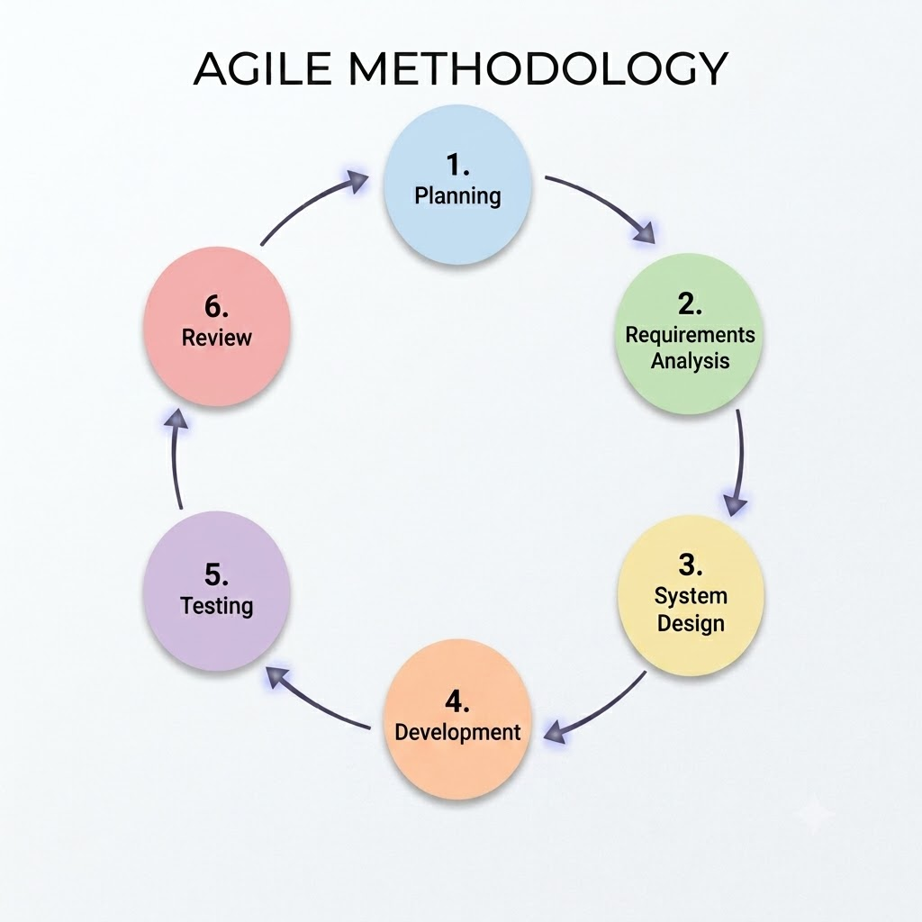

2.4 Emerging Technologies, Intelligent Systems, and Standards in
Modern Information Systems
Modern information systems continue to develop as organizations adopt emerging technologies to improve information management, data processing, and decision-making. These technologies are particularly useful in organizations that handle large amounts of information and require timely access to reliable data. In legislative environments, modern technologies can help reduce manual work, improve information retrieval, and provide additional support for policy analysis and decision-making.
The proposed system uses several technologies that are relevant to its objectives. These include Artificial Intelligence (AI), Natural Language Processing (NLP), Knowledge Base, Rule-Based System, web-based technologies, data analytics, and data visualization. These technologies are integrated to support legislative research, policy analysis, impact evaluation, and intelligent decision support.

Artificial Intelligence and AI-Assisted Analytics
Artificial Intelligence (AI) refers to technologies that allow computer systems to perform tasks that normally require human intelligence. These tasks may include analyzing information, identifying patterns, and generating useful insights.
In the proposed system, AI is used as an assisting technology for legislative research and policy analysis. AI-assisted analytics may help users summarize legislative documents, identify relevant information, and process data more efficiently. These functions may reduce the time required to manually review large amounts of legislative information.
However, AI-generated information should still be reviewed by authorized users. The system is not intended to replace the knowledge and judgment of legislative personnel or policymakers. Instead, AI is used to provide additional support that can help users process information and conduct research more efficiently.

Natural Language Processing
Natural Language Processing (NLP) is a technology that enables computer systems to process and analyze human language. It is useful in applications that handle large amounts of text-based information.
NLP is relevant to the proposed system because legislative documents such as ordinances, resolutions, and policy-related records contain a large amount of written information. The use of NLP may assist the system in processing these documents and identifying information that is relevant to a user's research needs.
NLP may also support document summarization and information retrieval. These functions can help users review lengthy documents more efficiently and locate relevant information without manually checking every document in the system.

Knowledge Base
A Knowledge Base is an organized collection of information that can be used by an intelligent system. In the proposed system, the Knowledge Base may contain relevant legislative information and other structured data needed to support research and decision-making.
The Knowledge Base provides information that can be used by other intelligent system components when generating analytical results or recommendations. Because of this, the information stored in the Knowledge Base should be properly organized and maintained to ensure that the system provides relevant and reliable results.

Rule-Based System
A Rule-Based System uses predefined rules and conditions to process information and provide results. In the proposed system, this component may be used to support policy analysis and intelligent decision support.
The use of predefined rules allows the system to apply consistent criteria when processing certain information. It can also provide a more structured basis for recommendations. However, the recommendations generated by the system are intended only to assist users and should not be treated as automatic or final legislative decisions.

Web-Based Information System
A web-based information system is an application that users can access through a web browser using an internet connection or local network. This type of system is suitable for the proposed project because it provides a centralized platform that can be accessed by authorized users.
The web-based structure of the proposed system can help address the problem of fragmented legislative information. Instead of keeping documents in different locations, the system provides a central platform where authorized users can manage and retrieve legislative records.
The centralized platform can also allow users to access legislative research, policy analysis, impact evaluation, and decision-support features in one system. This can reduce the need to switch between different applications or manually collect information from separate sources.

Data Analytics and Data Visualization
Data analytics involves examining and processing data to identify useful information, patterns, and insights. In the proposed system, data analytics may support users in examining legislative and policy-related information.
Data visualization complements data analytics by presenting information through charts, graphs, dashboards, and other visual formats. Visual representations can make complex information easier to understand and may help users identify trends and comparisons.
The proposed system may use dashboards and visual reports to present relevant information that can support legislative monitoring, policy analysis, and decision-making.

Information Security
Information security is an important consideration in modern information systems, particularly when handling government and legislative information. The proposed system should protect information from unauthorized access, modification, loss, or disclosure.
User authentication and role-based access control may be applied to ensure that only authorized users can access the system and its specific features. User permissions can also be assigned based on the responsibilities of each user.
Security measures are important because the proposed system is intended for authorized personnel and may contain legislative documents and information that require proper access control.

Data Quality and Reliability
The quality of data used by the system is important in producing reliable analytical results. AI-assisted analytics and intelligent decision support depend on the accuracy, completeness, consistency, and relevance of the information available in the system.
For this reason, legislative documents and related information should be properly organized and maintained. The system should also consider processes that help ensure that information is accurate and up to date. Poor-quality or incomplete information may affect the results generated by the system and may lead to incorrect conclusions.

Standards and System Quality
Modern information systems should consider software quality characteristics to ensure that they meet user requirements and perform their intended functions. Important quality areas include functionality, usability, performance efficiency, reliability, security, and maintainability.
These quality considerations are relevant to the proposed system because it should provide the required functions, respond efficiently to user requests, protect legislative information, and remain easy to use. The system should also be reliable enough to support legislative research and policy analysis.
Security and quality considerations are also important when developing intelligent systems. The system should provide understandable and useful results while maintaining appropriate controls over information access. Users should also be able to review and validate the information provided by the system before using it as part of their analysis.

Relevance of Emerging Technologies to the Proposed System
The emerging technologies included in the proposed system are selected based on the problems identified in the study. AI-assisted analytics and NLP can help reduce the manual effort involved in reviewing legislative documents. The centralized web-based platform can help organize fragmented information in one location. Data analytics and visualization can support policy analysis and impact evaluation, while the Knowledge Base and Rule-Based System can contribute to intelligent decision support.
The technologies used in the system are intended to support the work of legislative personnel rather than replace them. AI-generated summaries, analytical insights, and recommendations should be reviewed and validated by authorized users before being used for legislative purposes.
The proposed system therefore follows a human-centered approach in which technology provides assistance while human users remain responsible for interpretation, judgment, and final decision-making. This is important because legislative decisions involve public concerns and require proper evaluation and accountability from authorized officials.
Overall, the integration of AI-assisted analytics, NLP, Knowledge Base, Rule-Based System, web-based technologies, data analytics, data visualization, and information security considerations provides the technological foundation of the proposed system. These technologies are selected not only because they are modern but also because they directly support the identified needs of the project. Through their integration, the proposed system aims to provide a more organized and efficient approach to legislative research, policy analysis, and impact evaluation while maintaining human control over the final legislative decision-making process.
2.4.1 Microservices Architecture
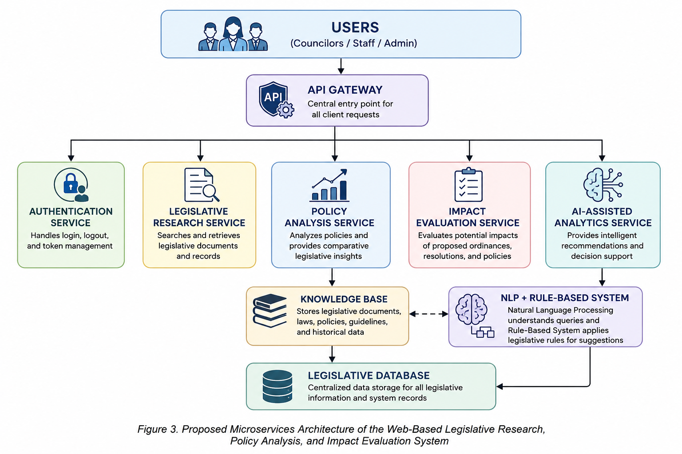
Overview
Microservices Architecture is a software design approach that structures an application into a collection of small, independent services, each responsible for a specific business function. Unlike a monolithic architecture, each service can be developed, deployed, and maintained independently, making the system more scalable, flexible, and easier to manage. This architectural approach has become widely adopted in modern web-based applications because it improves system performance, simplifies maintenance, and supports continuous development as organizational requirements evolve (Božić, 2023; Hannousse & Yahiouche, 2021).
In the proposed Web-Based Legislative Research, Policy Analysis, and Impact Evaluation System for Manila City Hall, Microservices Architecture is adopted to separate major system functions such as authentication, legislative research, policy analysis, impact evaluation, and AI-assisted analytics into independent services. This approach enhances maintainability, allows future system expansion, and ensures that updates to one service have minimal impact on the overall operation of the system

API Gateway
An API Gateway serves as the central communication point in a microservices architecture. It receives requests from users and routes them to the appropriate services, providing a unified access point for the entire system. This approach simplifies request handling, improves security, and reduces the complexity of communication between clients and multiple services.
In the proposed Web-Based Legislative Research, Policy Analysis, and Impact Evaluation System, the API Gateway manages requests from councilors, legislative staff, and administrators. It securely connects users to services such as legislative research, policy analysis, impact evaluation, and AI-assisted analytics, ensuring efficient and organized system communication
Service Discovery
Service Discovery is a mechanism that enables services within a microservices architecture to automatically locate and communicate with one another. Instead of using fixed addresses, services can dynamically find available services, which improves reliability and flexibility as the system grows.
For the proposed system, Service Discovery supports seamless communication among the legislative research, policy analysis, impact evaluation, and AI-assisted services. This allows the system to maintain stable and efficient interaction between modules even when services are updated, scaled, or redeployed
Containerization
Containerization is a deployment approach that packages an application together with its required libraries, dependencies, and configurations into a portable container. This ensures that the application runs consistently across different computing environments and simplifies deployment and maintenance.
In this study, containerization supports the deployment of the proposed system by allowing each service to operate independently while maintaining consistent performance. This approach improves scalability, reliability, and system management, making future updates and maintenance easier to perform

2.4.2 Artificial Intelligence (AI)
Artificial Intelligence (AI) refers to computer systems that can perform tasks that typically require human intelligence, such as processing information, recognizing patterns, understanding language, and providing recommendations. AI has become an important component of modern information systems because it helps automate processes and improve decision-making.
In the proposed Web-Based Legislative Research, Policy Analysis, and Impact Evaluation System, AI is used to support legislative personnel in retrieving relevant legislative documents, analyzing policy-related information, and providing intelligent recommendations. The system specifically utilizes a Knowledge Base, Natural Language Processing (NLP), and a Rule-Based System to deliver AI-assisted analytics and decision support.
Machine Learning
Machine Learning is a branch of Artificial Intelligence that enables computer systems to learn patterns from data and improve their performance without being explicitly programmed for every task. It is commonly used for prediction, classification, and recommendation systems.
Although Machine Learning is an important AI technology, it is discussed in this study as related literature and is not the primary approach implemented in the proposed system.
Deep Learning
Deep Learning is a specialized branch of Machine Learning that uses artificial neural networks to process large amounts of data and solve complex problems. It is widely used in image recognition, speech recognition, and advanced natural language processing.
Deep Learning is included in this study as related literature to provide background on advanced AI technologies; however, it is not implemented in the proposed legislative system.
Predictive Analytics
Predictive Analytics involves analyzing historical and current data to identify patterns and estimate future outcomes. Organizations use it to support planning and decision-making by generating data-driven insights.
In legislative environments, predictive analytics can help evaluate policy trends and potential impacts. However, the proposed system focuses on document retrieval, policy analysis, and decision support based on existing legislative records rather than forecasting future outcomes.
Generative Al
Generative AI is a type of Artificial Intelligence capable of creating new content such as text, summaries, images, or reports based on user input and existing data. It is increasingly used to improve productivity and assist users in processing information.
In the context of legislative systems, Generative AI has the potential to support document summarization and information retrieval. However, to ensure accuracy, transparency, and reliance on official legislative documents, the proposed system uses a Knowledge Base, Natural Language Processing (NLP), and a Rule-Based System instead of automated content generation
2.4.3 Internet of Things (IoT)
The Internet of Things (IoT) is a technology that connects physical devices, such as sensors and smart devices, to the internet, allowing them to collect, share, and exchange data automatically. It is commonly used in areas such as healthcare, transportation, agriculture, and smart cities to improve monitoring and decision-making (International Telecommunication Union [ITU], 2023). Although IoT is an important technology in many information systems, it is not directly used in the proposed Web-Based Legislative Research, Policy Analysis, and Impact Evaluation System, since the system focuses on managing legislative information rather than collecting data from physical devices.
2.4.4 Data Analytics and Business Intelligence
Data Analytics and Business Intelligence (BI) are important components of modern information systems because they help organizations transform large amounts of data into meaningful information for decision-making. Data analytics focuses on examining and interpreting data to identify patterns, trends, and valuable insights, while business intelligence provides technologies and processes that support data-driven decision-making.
According to Sharda, Delen, and Turban (2020), business intelligence enables organizations to collect, analyze, and present information that supports strategic and operational decisions. Through BI systems, organizations can monitor performance, identify opportunities, and improve decision-making processes using accurate and relevant data.
One of the essential components of business intelligence is data warehousing. Inmon (2005) defined a data warehouse as a centralized collection of integrated and organized data that supports reporting and analysis activities. Data warehouses allow organizations to store information from different sources, making it easier to retrieve and analyze data for decision-making purposes.
Reporting systems also play an important role in business intelligence by presenting analyzed information through reports, dashboards, and visualizations. According to Kimball and Ross (2013), effective reporting systems help users understand business performance and provide insights that can support planning and management decisions.
Overall, the use of data analytics and business intelligence improves the ability of organizations to utilize information effectively. These technologies support better decision-making, efficient operations, and improved management of information systems.
Data Analytics and Business Intelligence (BI) are important components of modern information systems because they help organizations transform large amounts of data into meaningful information for decision-making. Data analytics focuses on examining and interpreting data to identify patterns, trends, and valuable insights, while business intelligence provides technologies and processes that support data-driven decision-making.
According to Sharda, Delen, and Turban (2020), business intelligence enables organizations to collect, analyze, and present information that supports strategic and operational decisions. Through BI systems, organizations can monitor performance, identify opportunities, and improve decision-making processes using accurate and relevant data.
One of the essential components of business intelligence is data warehousing. Inmon (2005) defined a data warehouse as a centralized collection of integrated and organized data that supports reporting and analysis activities. Data warehouses allow organizations to store information from different sources, making it easier to retrieve and analyze data for decision-making purposes.
Reporting systems also play an important role in business intelligence by presenting analyzed information through reports, dashboards, and visualizations. According to Kimball and Ross (2013), effective reporting systems help users understand business performance and provide insights that can support planning and management decisions.
2.4.4 .1 AI-Assisted Analytics
AI-Assisted Analytics uses Artificial Intelligence (AI) to analyze, organize and summarize legislative information. In the proposed system, it helps legislative personnel review documents more quickly and supports policy analysis with relevant insights.

2.4.4.2 Knowledge Base
A Knowledge Base is a centralized collection of legislative documents, legal references, ordinances, and resolutions. It helps users quickly access the information needed for legislative research and policy analysis.

2.4.4.3 Rule-Based System
A Rule-Based System uses predefined rules to analyze legislative information and provide recommendations. It supports policy analysis by giving relevant guidance while leaving all final decisions to authorized personnel.

2.1.4.4 Natural Language Processing (NLP)
Natural Language Processing (NLP) is an AI technology that enables computers to understand and process human language. In the proposed system, it helps summarize documents, identify keywords, and improve document searching for faster legislative research.
Reporting Systems
A Reporting System is a tool that generates and presents information in an organized format. In the proposed system, it allows legislative personnel to create reports on legislative documents, policy analysis, and impact evaluation to support research and decision-making.
2.4.5 Polyglot Persistence
Polyglot Persistence is an approach in software architecture where different types of database technologies are used within a single system depending on the specific requirements of each application component.
Instead of using only one database solution, developers select different storage technologies that are more suitable for handling specific types of data and workloads.
According to Fowler (2011), polyglot persistence allows software systems to use multiple database technologies because each type of database provides different advantages. Relational databases are commonly used for structured data, while NoSQL databases are often used for flexible, large-scale, and unstructured data management.
Sadalage and Fowler (2012) explained that the use of NoSQL databases provides developers with alternative ways of managing data, particularly for modern applications that require scalability, flexibility, and high performance. Through polyglot persistence, organizations can choose appropriate database solutions based on the needs of different parts of a system.
However, implementing multiple database technologies requires careful planning because it may increase system complexity. Developers must consider factors such as data consistency, security, integration, and maintenance to ensure that different storage systems work effectively together.
In modern information systems, polyglot persistence provides flexibility in managing various data requirements. By selecting suitable database technologies, organizations can improve system performance, scalability, and adaptability.
2.4.6 Cybersecurity
Cybersecurity refers to the protection of computer systems, networks, and data from unauthorized access, cyber threats, and security risks. In the proposed system, cybersecurity helps protect legislative documents and user information through secure login, user authentication, and controlled access. It also supports compliance with the Cybercrime Prevention Act of 2012 (Republic Act No. 10175) by promoting the secure use of information systems and protecting digital information from unauthorized activities.
2.4.7 Data Privacy
Data Privacy refers to the proper collection, storage, use, and protection of personal information. In the proposed Web-Based Legislative Research, Policy Analysis, and Impact Evaluation System, data privacy helps ensure that legislative records and user information are accessed only by authorized personnel. The system supports the protection of personal data in accordance with the Data Privacy Act of 2012 (Republic Act No. 10173).

2.4.8 Software Quality Standards
Software Quality Standards are guidelines used to evaluate whether a software system meets the required level of quality. In this study, the proposed Web-Based Legislative Research, Policy Analysis, and Impact Evaluation System will be evaluated using the ISO/IEC 25010 Software Quality Model. The evaluation focuses on Functional Suitability, Usability, Performance Efficiency, and Compatibility to determine whether the system meets the needs of legislative personnel.
2.4.9 Cloud Computing
Cloud computing is a technology that allows users to store, manage, and access data and applications through the internet instead of using only a local computer or server. According to Jewargi (2023), cloud computing provides flexible access to computing resources and makes it easier to share and manage information. In the proposed Web-Based Legislative Research, Policy Analysis, and Impact Evaluation System for Manila City Hall, cloud computing can help store legislative documents securely and allow authorized users to access information anytime and from different locations. This supports faster document retrieval, better collaboration, and a more efficient legislative process.

2.4.10 Edge Computing
Edge Computing is a technology that processes data closer to where it is used instead of sending everything to a central server. According to Shi (2020), this approach helps reduce delays, improve system performance, and provide faster access to information. In the Web-Based Legislative Research, Policy Analysis, and Impact Evaluation System for Manila City Hall, edge computing can support faster access to legislative records and improve the system's response when multiple users access information at the same time.
2.5 DevOps Culture and CI/CD Practices
DevOps is a software development approach that helps developers work together more efficiently throughout the development process. Continuous Integration (CI) allows developers to combine code changes into one project, while Continuous Deployment (CD) helps release system updates more quickly and reliably.
In this study, GitHub is used to store the project's source code, manage updates, and support collaboration among the developers. It helps keep the latest version of the system organized and makes it easier to track changes during development.
2.6 Enterprise Architecture & System Integration
Enterprise Architecture (EA) offers a systematic method for designing and overseeing information systems, ensuring that business processes, data assets, applications, and technology infrastructure are consistently aligned with organizational goals. In this initiative, EA is implemented through The Open Group Architecture Framework (TOGAF), which serves as the foundational methodology for developing a web-based system aimed at supporting legislative research, policy analysis, and impact assessment for Manila City Hall. TOGAF is particularly suited to this project because it enables a coherent alignment between institutional needs and technical design. This structured approach helps address current inefficiencies—such as reliance on manual processes in policy evaluation and delays in legislative decisions—while promoting more timely, effective, and data-informed policymaking.
System integration in enterprise settings refers to the general scope of processes and activities related to linking disparate information systems, applications, and technologies in order to maximize organizational effectiveness and achieve greater degree of system coherence. It allows for harmonizing diverse system functions under a common framework while still ensuring the degree of information and service availability, security, and reliability. In many cases, system integration helps realize a broader level of organizational efficacy by minimizing the excessive fragmentation of systems and processes and maximizing their accessibility.For the Web-Based Legislative Research, Policy Analysis, and Impact Evaluation System for Manila City Hall, system integration is essential in terms of unifying the diverse aspects of legislative research, policy analysis and impact evaluation, AI-based analytics and decision-making support, and intelligent system components under one common system architecture and framework.

2.7 Conceptual Framework
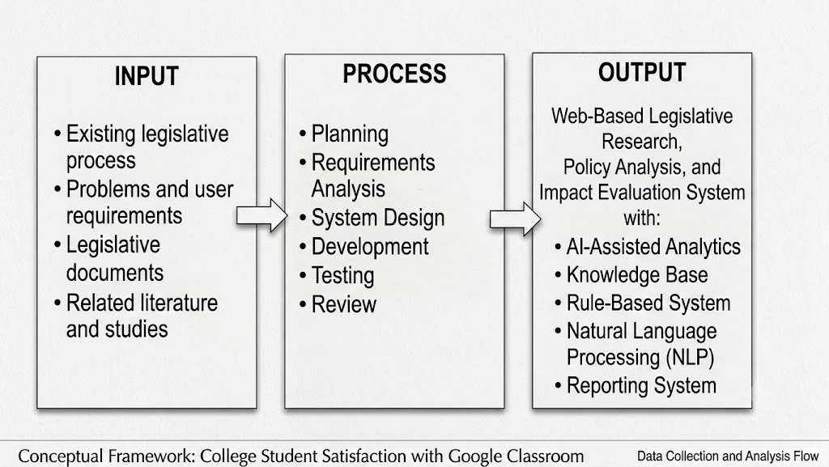

2.8 Theoretical Paradigm
The theoretical framework of the proposed study is based upon Socio-technical systems theory. The theory highlights the interdependence between social and technical aspects of organizational systems. It also states that the success of information systems is determined by its capacity to meet the needs of an organization through appropriate consideration of people, processes, and technologies. In the case of the proposed system, the social dimension includes legislators, researchers, and IT personnel. The technical features of the system include the website, legislative research, policy analysis, impact evaluation, AI driven analyses, and decision support. The theory is applied to develop a solution that considers user requirements and organizational processes. In this case, it will ensure that the system meets the needs of its users while addressing the challenges associated with policy analysis and delayed legislative processes.

\REFERENCE
International Telecommunication Union. (2023). Challenges of and guidelines to standardization on Artificial Intelligence of Things (AIoT). https://www.itu.int/epublications/publication/itu-t-ystp-aiot-2023-09-challenges-of-and-guidelines-to-standardization-on-artificial-intelligence-of-things

Jewargi, K. (2023). What is cloud computing: Benefits and challenges of cloud. Global Journal of Computer Sciences: Theory and Research, 13(1), 28–33. https://doi.org/10.18844/gjcs.v13i1.8622

Shi, W. (2020). Edge computing: Vision and challenges. IEEE Internet of Things Journal. https://doi.org/10.1109/JIOT.2016.2579198

Tabuga, A. D. (2024). Assessing analytical capacities in local government policymaking: The case of 20 percent Local Development Fund. Philippine Institute for Development Studies. Retrieved from https://www.pids.gov.ph/research/public/view?id=1508

Diary Jane F. Palec. "Legislative Innovation and Adaptive Governance Practices: Inputs to Participatory Policy-Making Framework Plan in the Province of Iloilo." International Journal of Management Studies and Social Science Research, 2026. https://www.ijmsssr.org/paper/6a0d631ad96cc.pdf
Rachid Ejjami. "AI-driven Justice: Evaluating the Impact of Artificial Intelligence on Legal Systems." International Journal For Multidisciplinary Research, 2024. https://doi.org/10.36948/ijfmr.2024.v06i03.23969.
Arlen A. Limen, Nichole E. Faulan, Kaye B. Vegafria, June Earl M. Estilo. "Development and Implementation of SEIMS in One Local Community in the Philippines." International Journal of Innovative Science and Research Technology, 2026. https://www.ijisrt.com/development-and-implementation-of-seims-in-one-local-community-in-the-philippines
Grepon, B. G. S. (2021). Designing and implementing e-justice systems: An information systems approach to regional trial court case docket management in Northern Mindanao, Philippines. arXiv.https://arxiv.org/abs/2103.06412

